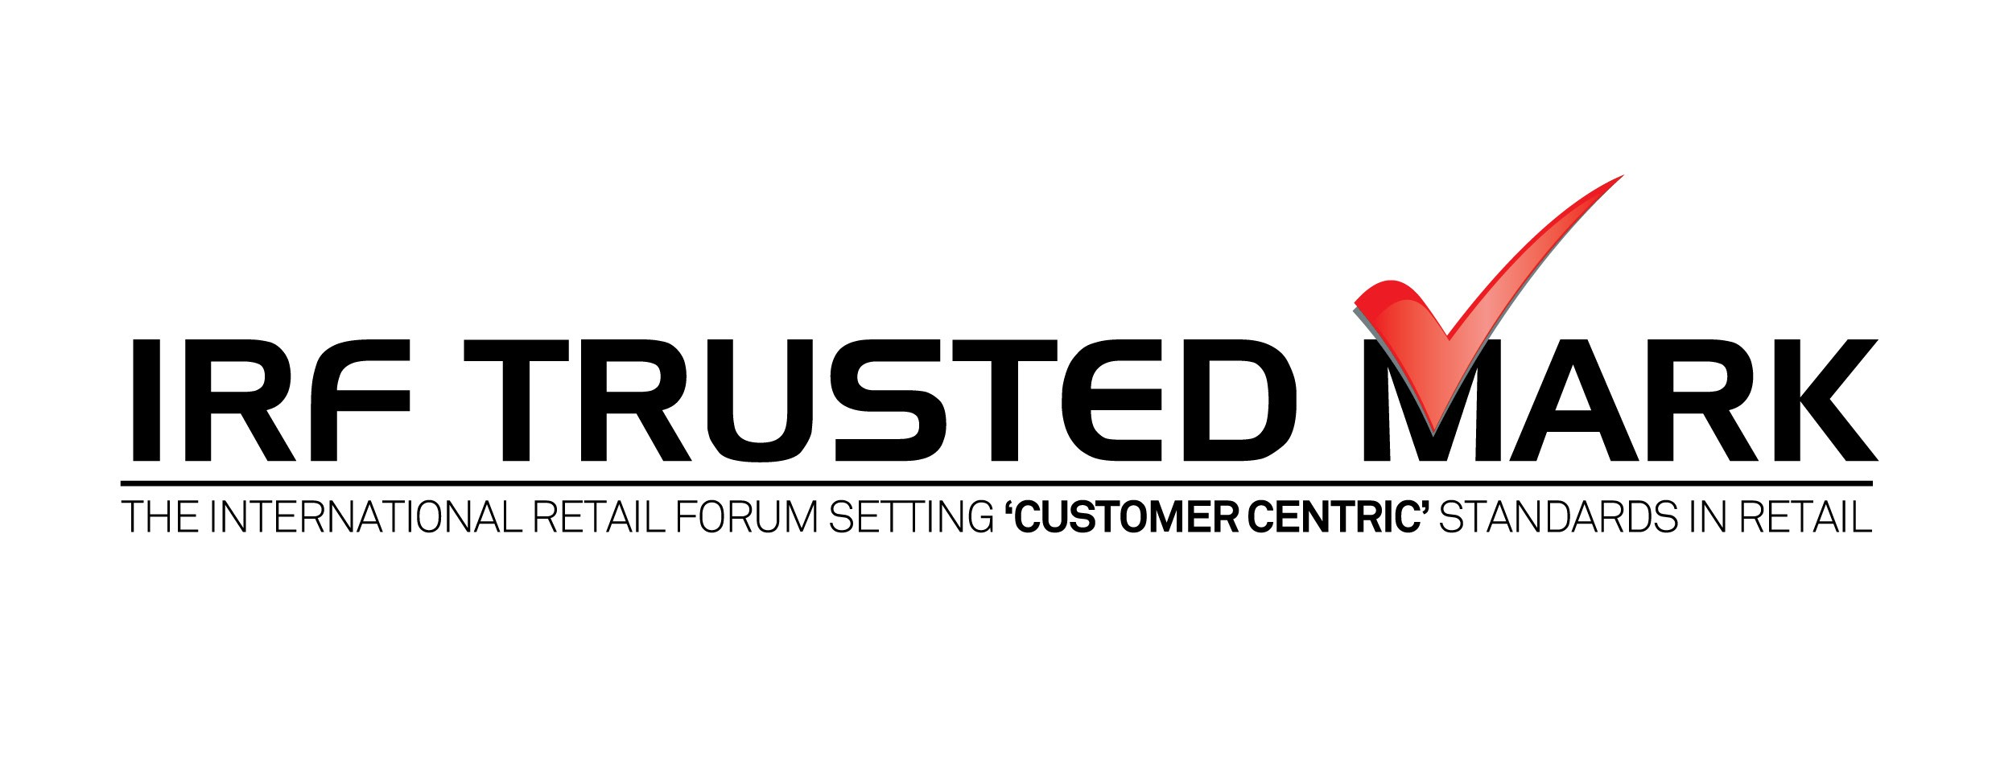
TRUSTED Mark® SCHEME
Trust 204:
Self Evaluation by Client/ Weightage System/
Explanation of Audit Value Ratings

On finalisation of a Certification Body (CB), client will receive an Excel file with
several sheets with scores/ weights assigned to all criteria. Based on
applicant’s declaration of meeting criteria requirements in the file, the final score will
automatically calculate the total points that the applicant can aspire for in the scheme.
Points should be assigned only if the declaration can be supported with documentary
proof to the assessor during the assessment process. Minimum 70 score is required to
qualify for the Trusted Mark.

Total Score | Tick Mark to Select Your Level  after self-evaluation and calculating your points in Excel File.
70 to 79.9
80 to 89.9
90 to 100

For Applicants other than Shopping Centres & Mall Management Companies:
Weightage score | Standard Heading
10 | A. Regulatory Compliance (A.1 – A.4)
2 | B. Practices and Systems – 1. Environment Sustainability (B1.1 – B1.3)
5 | B. Practices and Systems – 2. HR practices (B.2.1 – B.2.6)
5 | B. Practices and Systems – 3. Communication (B.3.1 – B.3.5)
8 | B. Practices and Systems – 4. Goods and Services (B.4.1 – B.4.5)
8 | B. Practices and Systems – 5. Terms and conditions of sale (B.5.1 – B.5.5)
8 | B. Practices and Systems – 6. Transactions and Accounting (B.6.1 - B.6.3)
4 | B. Practices and Systems – 7. IT Ecosystem (B.7.1 – B.7.5)
20 | C. Customer Care – 1. Customer Service, Feedback and Dispute Resolutions (C.1.1 - C.1.3)
20 | C. Customer Care – 2. Customer data, their safety & privacy (C.2.1 – C.2.6)
10 | C. Customer Care – 3. Customer Service, Feedback and Dispute Resolutions (C.3.1 – C.3.6)
100 | Total

For Shopping Centres & Mall Management Companies:

Weightage score | Standard Heading
10 | A. REGULATORY COMPLIANCE
6 | B. PRACTICES & SYSTEMS - 1. ENVIRONMENT SUSTAINABILITY
6 | B. PRACTICES & SYSTEMS - 2. HR PRACTICES
8 | B. PRACTICES & SYSTEMS - 3. COMMUNICATION
6 | B. PRACTICES & SYSTEMS - 4. GOODS & SERVICES
8 | B. PRACTICES & SYSTEMS - 5. TERMS & CONDITIONS OF HOSTING
6 | B. PRACTICES & SYSTEMS - 6. IT & DIGITAL INFORMATION
25 | C. PRACTICES & SYSTEMS - 7. CENTRE SERVICES, FEEDBACK, DISPUTE RESOLUTION
25 | C. PRACTICES & SYSTEMS - 8.CENTRE SAFETY, SECURITY & HYGIENE
100 | Total

Explanation of Audit Value Ratings
Audit Score Points (ASP)
BLANK | Not Applicable (NA) | The standard is Not Applicable (NA) to the applicant
0 | No Conformity | Non-Conformity to the standard
1 | Conformity Deficient | The standard is documented but not followed
2 | Improvement Needed | The standard / process is in practice but neither properly documented nor executed appropriately. There is a high probability that the standard / system will not produce required results. Improvements to the process / documentation are required.
3 | Acceptable | The standard / process is included in the system. Planning and execution meet these standards. There is a high probability that the system will produce required results
4 | Outstanding | The standard / process is included in the system. Planning and execution are thorough and exceed these standards. It is certain that the system will produce exemplary results

For clarifications contact any approved certification body or Trusted Mark Secretariat
S 61A, Okhla Industrial Area, Phase II, New Delhi - 110 020 India, Ph: +91 11 40525000
Email – rsroy@irftrustedmark.org | www.irftrustedmark.org

