Trust 201: ‘TRUSTED MARK’ Certification Scheme Application Process
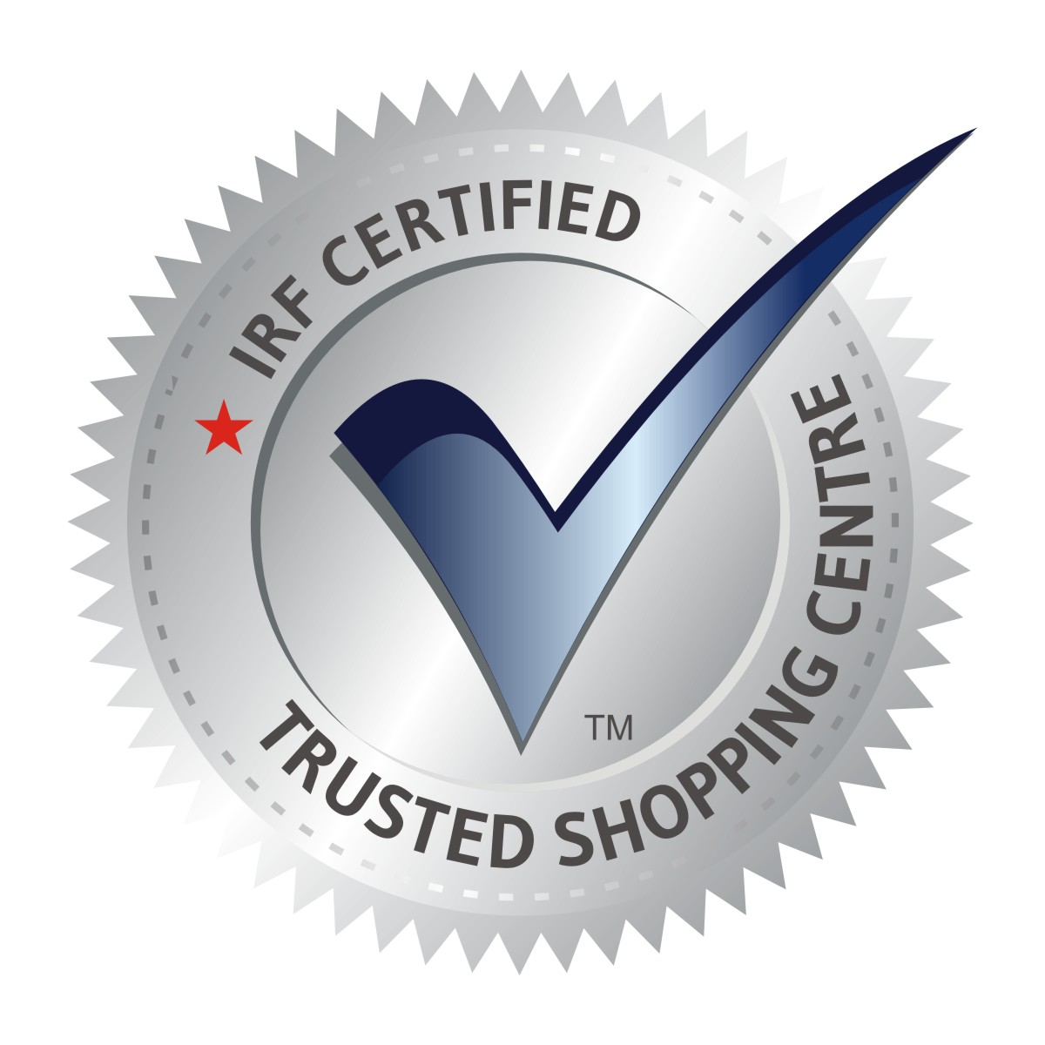

Application Form:

TRUSTED MARK Certification scheme

Applicable to Retail Real Estate Owners, Developers, Shopping Centre Management Organisations and Facility/Operations Management Companies seeking the 'TRUSTED SHOPPING CENTRE' Certification Mark

Application Form - Instructions
The Applicant may be the owner/developer of the Shopping Centre or an organisation responsible for its management and/or operations.
A separate application shall be submitted for each Shopping Centre seeking certification.
Please read the ‘Application Terms & Conditions’ provided at the end of this Application Form before completing and signing the Application.
Please type or write clearly using black or blue ink. Where not applicable, please fill in the blanks as NA. Delete where appropriate.
Please note that blank answers may result in processing delay.
Attach separate sheets if space provided is insufficient.

PARTICULARS OF YOUR BUSINESS
Name of Organisation :
H.O. Address:
CIN/ Establishment Reg. no.: | Date of Registration:
Name of Shopping Centre Seeking Certification: | Date of Commencement of Operations: | Website:
Address with Location, City, State with Pincode :

CONTACT PARTICULARS
Name of Organisation Head: Dr/Mr/Ms | Designation of Organisation Head:
Contact Person for the purpose of certification:  Name: Dr/Mr/Ms | Designation  Email:
Tel: | Mobile:

Consultant (if engaged) for ‘TRUSTED MARK’ Certification
Consultancy Firm: | Contact Person:
Mobile: | Email:

SIZE OF APPLICANT SHOPPING CENTRE
Total Project Area: | Total Built Up Area in Sq. Ft. | Total GLA n Sq. Ft.
Total Common Area in Sq. Ft. | Total Carpet Area in Sq. Ft. | Total Service Area in Sq. Ft.

SHOPPING CENTRE TYPE – PLEASE TICK MARK AND MENTION %
☐ Leased | ☐ Partly Sold | ☐ Strata | ☐ Other – Please specify:

TOTAL NO. OF TENANTS
No. of Anchors | No. of Vanilla Stores | No. of Kiosks

FOOTFALLS
Average Weekday Footfall | Average Weekend Footfall | Peak Daily Footfall

SPACE ALLOCATION – PLEASE INDICATE APPROXIMATE % OF GLA |  | MALL OCCUPANCY: %
Fashion & Lifestyle: % | Food & Grocery: % |  | Leisure & Entertainment: %
F&B: % | Home & Electronics: % |  | Others: %

UTILITIES
No. of Customer Entry Gates: | No. of Customer Exit Gates: | No. of Service/ Other Entry Points: | No. of Service/ Other Exit Points:
No. of Floors GF & above: | Basement Levels:
No. of Guests Lifts: | No. of Service Lifts: | No. of Escalators: | No. of Emergency Stairs:
Parking Space in Sq. Ft. | No. of Parking Levels: | 2-wheeler parking capacity: | 4-wheeler parking capacity:
No. of Washrooms: | No. of Medical Rooms:

STAFFING
Own Employees Count:

EXTERNAL PROFESSIONAL AGENCIES INVOLVED
Mall Management & Ops: | Staff Deployed:
Parking Management: | Staff Deployed:
Fire Safety: | Staff Deployed:
Security Management: | Staff Deployed:
Housekeeping: | Staff Deployed:
Engineering/Facility Management: | Staff Deployed:
Others (Please Mention): | Staff Deployed:

SIGNED DECLARATION
I / We hereby declare and confirm that:
- All information, declarations, documents and particulars provided in this Application are complete, accurate and truthful to the best of my/our knowledge.
- I / We have read, understood and agree to be bound by the Application Terms & Conditions and the applicable requirements of the IRF TRUSTED MARK Certification Scheme.
- The declarations relating to applicable laws, statutory and regulatory requirements, including those submitted under Annexure A, are accurate and may be verified at any stage of the application, audit or certification cycle. Any material misrepresentation, omission or discrepancy may result in rejection of the Application or appropriate action regarding certification in accordance with the Scheme requirements.
- The Applicant, or any of its Directors / Partners / Owners, has previously been rejected, suspended or removed from any certification scheme, including but not limited to the IRF TRUSTED MARK Certification Scheme:
☐ No ☐ Yes – If Yes, please provide details below or attach a separate sheet:

- The Applicant, or any of its Directors / Partners / Owners, has been convicted of any criminal offence or found to have committed any serious regulatory violation relevant to its business:
☐ No ☐ Yes – If Yes, please provide details below or attach a separate sheet:

- The Applicant is committed to serving customers and visitors and to continually improving its systems, processes, facilities and services. For certification under the 'TRUSTED SHOPPING CENTRE' Certification Mark, the Applicant undertakes to comply with the applicable IRF TRUSTED MARK Certification Standard and Scheme requirements.
- The Applicant authorises the IRF Trusted Mark Secretariat, its authorised representatives, Certification Bodies and Mystery Audit agencies engaged under the Scheme to capture photographs, video and audio recordings, where required, solely for certification, surveillance, investigation and Mystery Audit purposes and in accordance with applicable Scheme requirements. The Applicant further indemnifies the Scheme Owner, Certification Bodies and authorised audit agencies against claims arising solely from such activities undertaken in accordance with the Scheme.

Authorised Signature: CEO / Director / CFO/Owner | Business Stamp:
Name: | Designation:
Date:

Documents to accompany the Application
- Completed Application Form  - Application Fee | - Copy of Certificate of Incorporation / Registration  - GST Registration  - PAN | - Latest Business Profile (not older than three months)  - Shopping Centre logo (soft copy)

Fee Structure – Per Shopping Centre
Fee | Less than  1 Lakh Sq. Ft. | 1 Lakh to  5 Lakh Sq. Ft. | Above 5Lakh  Sq. Ft.
Application Fee | Rs. 5,000 | Rs. 7,500 | Rs. 10,000
Mystery Audit Fee | As per visit/ man day calculations– to be paid to IRF TRUSTED MARK LLP
CB Audit and Yearly Surveillance Fee* | Rs. 30,000  2 Mandays | Rs. 45,000  3 Mandays | Rs. 60,000  4 Mandays
Full Term Management Fee | Rs. 50,000 | Rs. 75,000 | Rs. 1,00,000
Annual ‘TRUSTED MARK’ mark usage: Logo incorporation in ‘TRUSTED MARK’ Certification Mark consumer & trade campaign | Rs. 50,000 | Rs. 75,000 | Rs. 1,00,000
Display Certificate Fee | Rs. 1,000 per certificate
Review Fee in case the applicant fails the audit by chosen CB and applies for review of the audit process | Rs. 1,000 | Rs. 5,000 | Rs. 10,000
*Indicative audit duration based on Trust 202 at ₹15,000 per manday. Final audit duration shall be determined by the Certification Body in accordance with Trust 202 and applicable Scheme requirements.
Applicable GST Extra

Details for remittance of all fees payable to TM Secretariat:

In favour of “IRF TRUSTE D MARK LLP” by cheque/ demand draft./ bank transfer.
• PAN Number: AA GFI 1315Q • LLPIN : AAI-2150
• Bank Account No.: 0812117224 • IFSC Code: KKBK0000195
• Bank Name: Kotak Mahindra Bank • Bank Address: Pamposh Enclave, GK-1, New Delhi-110048

Mailing Address:
R S Roy, Trusted Mark Secretariat
S-61A, Okhla Industrial Area, Phase II, New Delhi-110020, India
Telephone No. : +91-11-40525000, Fax No. : +91-11-40525001

APPLICATION TERMS & CONDITIONS

IRF TRUSTED MARK Certification Scheme

1. General
1.1 The Applicant shall be bound by these Application Terms & Conditions and by the applicable standards, requirements, procedures and guidelines of the IRF TRUSTED MARK Certification Scheme, as amended from time to time by IRF Trusted Mark LLP (the Scheme Owner).
1.2 All information, declarations, documents and evidence submitted by the Applicant shall be complete, accurate and authentic. The Applicant shall promptly inform the IRF Trusted Mark Secretariat and/or the engaged Certification Body (CB), as applicable, of any material change affecting the information submitted or the scope of certification.
1.3 Businesses having different CIN, GSTIN and/or applicable establishment registration numbers may be treated as separate legal/business entities and may be required to submit separate applications, as determined by the Scheme Owner having regard to their ownership, management and operations.
1.4 The Scheme Owner may revise the Scheme requirements, standards, procedures, fees and these Terms & Conditions from time to time. Applicants and certified organisations shall comply with applicable revised requirements within such transition period as may be prescribed.

2. Eligibility & Regulatory Compliance
2.1 The Applicant shall comply with all applicable laws, rules, regulations, licences, registrations, permits, approvals and statutory requirements relevant to its business and the scope of certification.
2.2 The Applicant shall disclose any material prosecution, conviction, serious regulatory violation, suspension, withdrawal or rejection from any certification scheme that may reasonably affect its eligibility for certification.
2.3 Where material non-compliance with applicable statutory or regulatory requirements is established during the application or certification cycle, the Certification Body and/or Scheme Owner may initiate appropriate action in accordance with the Scheme, including suspension or withdrawal of certification, as applicable.

3. Certification Process
3.1 Certification shall be subject to successful completion of the applicable Scheme requirements, which may include Application Review, Self-Evaluation, Mystery Audit, Document Review/Remote (e-Audit), Certification Audit, closure of applicable Nonconformities and a positive certification decision by the engaged Certification Body.
3.2 The Applicant shall provide the IRF Trusted Mark Secretariat, Certification Body and authorised Mystery Audit agency with reasonable access to applicable premises, facilities, personnel, documents, records, systems and other objective evidence necessary for assessment under the Scheme.
3.3 Certification and Surveillance Audits may be conducted through On-site, Remote (e-Audit) or Hybrid Audit methodology, as determined by the Certification Body in accordance with the applicable Scheme requirements.
3.4 The Applicant shall submit all required documents and audit-related information to the selected Certification Body within six (6) months from the date of finalising the CB. Failure to do so may result in closure of the application.
3.5 Where documents or information submitted during Document Review/Remote (e-Audit) are found incomplete or inadequate, the Applicant shall submit the required corrective actions and supporting information within the prescribed timeframe. Failure to do so may result in closure of the application.
3.6 Where the certification process is not completed within the period prescribed under the Scheme for reasons attributable to the Applicant, the application may be treated as closed and a fresh application and applicable fees may be required.

4. Fees & Payments
4.1 All applicable fees shall be payable in accordance with the prevailing fee structure of the IRF TRUSTED MARK Certification Scheme and the applicable certification programme. Applicable taxes and statutory levies shall be charged additionally.
4.2 The Application Fee, Mystery Audit Fee, Full-Term Management Fee, Annual 'TRUSTED MARK' Usage Fee, Review Fee and charges for certificates, plaques, stickers, hangtags and other Scheme material, where applicable, shall be payable to the IRF Trusted Mark Secretariat.
4.3 Certification Body audit fees, including fees for the initial Certification Audit, Surveillance Audits, follow-up/re-audits and other applicable CB audits, shall ordinarily be payable directly by the Applicant to the engaged Certification Body. Where the Applicant issues a single Purchase Order covering applicable Scheme and audit fees and elects to make a consolidated payment to the IRF Trusted Mark Secretariat, the Secretariat may receive such payment and remit the applicable audit fee to the engaged Certification Body.
4.4 During on-site audits, the Applicant shall facilitate reasonable local transportation and working arrangements for the Certification Body audit team, where applicable and as mutually agreed with the Certification Body.
4.5 Fees paid to the IRF Trusted Mark Secretariat shall be non-refundable, unless otherwise expressly agreed in writing by the Scheme Owner.
4.6 The applicable 'TRUSTED MARK' Usage Agreement shall be executed and the Certification Mark authorised for use only after completion of the prescribed certification and commercial formalities.

5. Certification Validity, Surveillance & Continued Conformity
5.1 Certification shall normally remain valid for three (3) years from the date of the Certification Body's certification decision, subject to continued conformity with the applicable Trust Standard and successful completion of the applicable surveillance and other assessment requirements prescribed under the Scheme.
5.2 A certified organisation shall undergo periodic Surveillance Audits at the frequency prescribed for the applicable certification programme.
5.3 Where prescribed under the applicable certification programme, the certified organisation may additionally be subject to Surprise/Unannounced Audit(s), Mystery Audit(s), Special Audit(s) or other assessments during the certification cycle.
5.4 The Scheme Owner may, where justified by complaints, significant concerns, credible information or material changes affecting certification, request the Certification Body to undertake a special or additional audit. Any certification decision arising from such CB audit shall remain solely the responsibility of the Certification Body.
5.5 Material changes including changes in ownership, legal status, management, business operations, certified premises/locations or certification scope shall be communicated promptly to the IRF Trusted Mark Secretariat and the Certification Body. Such changes may require review, additional assessment or amendment of certification.
5.6 The certified organisation shall maintain conformity with the applicable Trust Standard and applicable statutory and regulatory requirements throughout the certification period.
5.7 The Applicant/certified organisation shall maintain an appropriate mechanism for handling customer complaints and disputes and shall cooperate with any legitimate investigation undertaken in accordance with the Scheme.

6. Failure of Audit, Re-Audit & Review
6.1 Where the Applicant does not meet the applicable certification requirements, the Certification Body may require corrective action, follow-up verification, partial re-audit or complete re-audit, as applicable.
6.2 Any applicable follow-up or re-audit fee shall be payable by the Applicant to the Certification Body in accordance with mutually agreed commercial terms.
6.3 An Applicant dissatisfied with the audit process or outcome may submit a request for review to the IRF Trusted Mark Secretariat, together with reasons and the applicable Review Fee.
6.4 Upon receipt of a valid review request, the appropriate review mechanism under the Scheme shall examine the matter in consultation with the Certification Body while maintaining the independence and impartiality of the Certification Body's certification decision.
6.5 Where the review is decided in favour of the Applicant, the Review Fee may be refunded and any further assessment considered necessary shall be undertaken in accordance with the applicable Scheme procedures.

7. Confidentiality & Data Protection
7.1 Information and documents submitted by the Applicant shall be treated as confidential and shall be used only for purposes connected with the administration, audit, certification, surveillance, investigation and management of the IRF TRUSTED MARK Certification Scheme, except where disclosure is required by law, accreditation requirements or applicable Scheme requirements.
7.2 The Scheme Owner, Certification Body and authorised agencies shall implement reasonable measures to protect confidential information and personal data received or accessed during the certification process.
7.3 The Applicant authorises the sharing of information relevant to certification between the IRF Trusted Mark Secretariat, engaged Certification Body, Mystery Audit agency, accreditation body and other authorised parties where necessary for the administration, assessment, oversight or verification of the Scheme.
7.4 Certification status and appropriate certification particulars, including the certified organisation's name, certification scope, certified premises/locations, certificate number, validity and certification status, may be published by the Scheme Owner and/or Certification Body.

8. Limitation of Liability
8.1 Certification under the IRF TRUSTED MARK Certification Scheme represents conformity with the applicable Scheme requirements based on evidence assessed during the certification process and shall not constitute a warranty or guarantee regarding every product, service, facility, transaction, activity or operation of the certified organisation.
8.2 Neither IRF Trusted Mark LLP, the IRF Trusted Mark Secretariat, the Certification Body nor their authorised representatives or agencies shall be responsible for any loss, damage, injury, claim, dispute or liability arising from the Applicant's or certified organisation's products, services, facilities, premises, transactions, operations or dealings with customers, visitors, occupants, tenants, employees, service providers or any third party.
8.3 Certification shall not transfer, replace or reduce the Applicant's responsibility for compliance with applicable laws or for the quality, safety and performance of its products, services, facilities and operations.

9. Indemnity
9.1 The Applicant/certified organisation shall indemnify and hold harmless IRF Trusted Mark LLP, the IRF Trusted Mark Secretariat, the engaged Certification Body and their authorised representatives and agencies against claims, losses, liabilities, damages, costs or expenses arising from:
a. the Applicant's products, services, facilities, premises, business operations, customer transactions or dealings with customers, visitors, occupants, tenants, employees, service providers or other third parties;
b. breach of applicable laws or regulatory requirements by the Applicant;
c. inaccurate, misleading or incomplete information provided by the Applicant;
d. misuse or unauthorised use of the applicable 'TRUSTED MARK' Certification Mark; or
e. breach of these Terms & Conditions or applicable Scheme requirements,
except to the extent directly resulting from proven wilful misconduct or gross negligence of the party seeking indemnification.

10. Use of the 'TRUSTED MARK' Certification Mark
10.1 The applicable Certification Mark, certificate, logo and related Scheme material shall be used only in accordance with the 'TRUSTED MARK' Usage Agreement and guidelines issued by the Scheme Owner.
10.2 Certification shall not be represented in a manner that is misleading or implies certification of products, services, premises, locations or activities outside the approved certification scope.
10.3 Upon suspension, withdrawal, expiry or termination of certification, the organisation shall discontinue use of the Certification Mark and all claims of valid certification as directed by the Scheme Owner and/or Certification Body.

11. Suspension, Withdrawal & Termination
11.1 Certification may be suspended or withdrawn for reasons including material non-conformity, failure to maintain Scheme requirements, serious statutory or regulatory non-compliance, misuse of the Certification Mark, failure to complete applicable surveillance or other assessment requirements, non-payment of applicable Scheme fees or other material breach of certification conditions.
11.2 Where certification is suspended, the organisation shall not represent itself as holding active certification during the period of suspension.
11.3 Upon withdrawal, expiry or termination of certification, the organisation shall cease using the applicable 'TRUSTED MARK' Certification Mark, certificates, plaques, stickers, hangtags and other representations of certification in accordance with instructions issued by the Scheme Owner and/or Certification Body.

12. Consultancy & Independence
12.1 Where an Applicant chooses to engage a consultant for implementation or certification-preparation support, such engagement shall be entirely at the Applicant's discretion and responsibility.
12.2 Any consultant engaged by the Applicant shall be independent of the IRF Trusted Mark Secretariat and the engaged Certification Body. Neither the Scheme Owner nor the Certification Body shall be responsible or liable for advice, services or recommendations provided by such consultant.
12.3 Engagement of a consultant shall not guarantee certification or influence the independent audit, review or certification decision of the Certification Body.

13. Governing Law & Jurisdiction
13.1 These Application Terms & Conditions and participation in the IRF TRUSTED MARK Certification Scheme shall be governed by the laws of India.
13.2 Any dispute arising between the Applicant and IRF Trusted Mark LLP relating to the administration of the Scheme that cannot be resolved amicably shall be subject to the jurisdiction of the competent courts at New Delhi, India.
13.3 Disputes relating specifically to Certification Body audits or certification decisions shall be addressed through the applicable Certification Body's complaints and appeals process and the applicable Scheme requirements.

